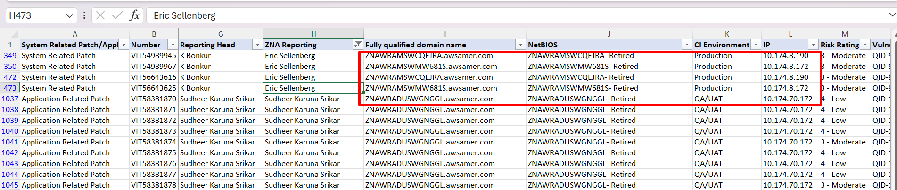

Server name: ZNAWRAMSWCQEJRA.awsamer.com
IP: 10.174.8.190
Not pingable
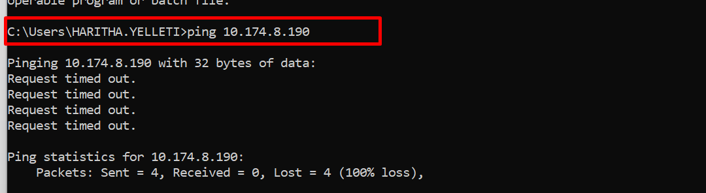
Server Name: ZNAWRAMSWMW681S.awsamer.com
IP: 10.174.8.172
Not Pingable
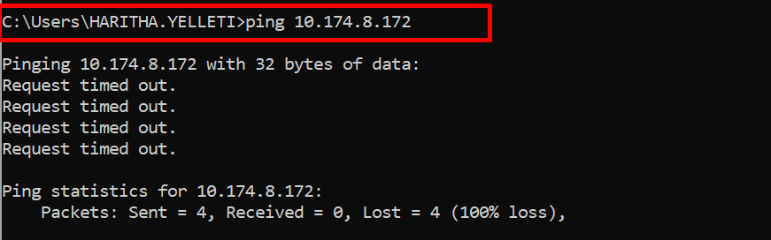
Server Name: ZNAWRADUSWGNGGL.awsamer.com
IP: 10.174.70.172
Pingable
